**Neural network for RP2 oscillations**

**Single neuron dynamics**

$C\frac{dV_{k}}{dt}=-g_{L}\left(V_{k}-V_{L}\right)-w_{k}+g_{L}∆_{T}\exp\left(\frac{V_{k}-V^{T}}{∆_{T}}\right)+I_{in}^{k}+I_{gap}^{k, m}+{\overline{w}}_{in}I_{ext}$ (1)

$τ_{w}\frac{dw_{k}}{dt}=a\left(V_{k}-V_{L}\right)-w_{k}$ (2)

Intrinsic heterogeneity: bursters and excitable cells

**Synaptic current**

$τ_{s}\frac{dI_{in}^{k}}{dt}=-I_{in}^{k}+\sum_{i=1}^{N}{\sum_{j=1}^{sp}{δ_{i}(t-t_{j})}}$ (3)

**Gap-junction current**

$I_{gap}^{k, m}={±g}_{gap}(V_{k}-V_{m})$ (4)

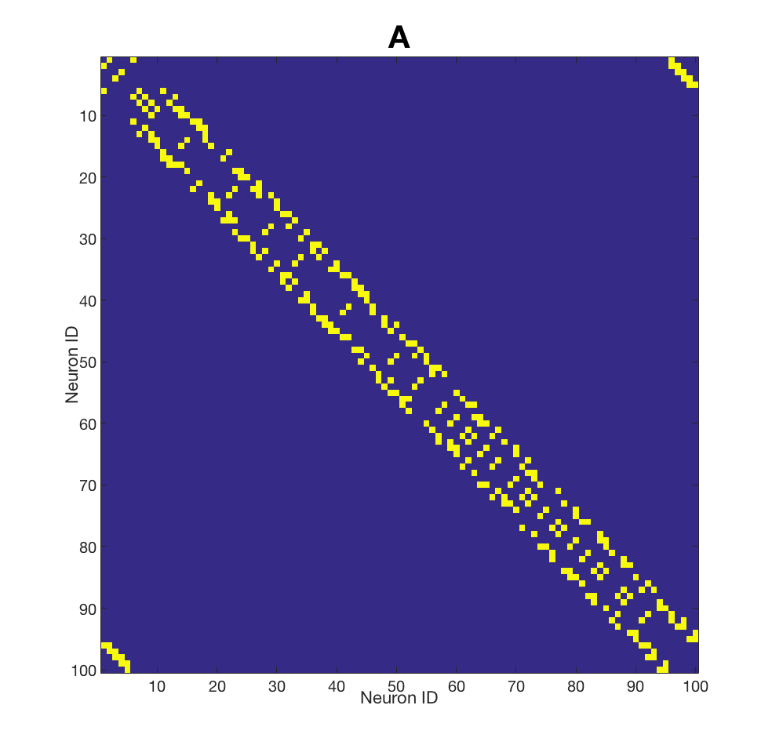

**Connectivity**

N – number of neurons

S – number of sensors

A – number of actuators

sp – spikes in the spike train

$\overline{w_{in}}$– vector of sensory input

**Indexes**

k – index over neurons

i – index over synapses

j – index over spikes

Summation over synaptic connections is organised by sparse connectivity matrix **A**